* + Consider a problem with four variables, {A,B,C,D}. Each variable has domain {1,2,3,4}.

The constraints on the problem are that A > B, B < C, A = D, C ≠ D.

Suppose that we want to solve this problem with local search using Iterative Best Improvement.

Assume we start with the following “random” assignment of values to variables shown in the first line.

Use a two-stage choice algorithm to find a satisfying assignment of the variables.

That is, first choose (one of the) variable(s) that participates in the most conflicts. Then choose a value of that variable that minimizes the number of conflicts for that variable. Then repeat so long as there are conflicts.

To determine if there are conflicts, fill out the “evaluation” column with the number of constraints that are not satisfied with the given assignment.

Keep going until you have no conflicts. (You may not need all the lines.)

***Solution***: Here are a couple examples

|  |  |  |  |  |  |  |  |  |
| --- | --- | --- | --- | --- | --- | --- | --- | --- |
| A | B | C | D | Evaluation | Conflicts participated in | | | |
| A | B | C | D |
| 1 | 2 | 3 | 4 | 4 | || | | |  | | |
| 4 | 2 | 3 | 4 | 0 |  |  |  |  |
|  |  |  |  |  |  |  |  |  |
| 4 | 3 | 2 | 1 | 4 | | | | | | | | |
| 1 | 3 | 2 | 1 | 4 | | | || |  |  |
| 1 | 1 | 2 | 1 | 2 | | | | |  |  |
| 4 | 1 | 2 | 1 | 2 | | |  |  | | |
| 4 | 1 | 2 | 4 | 0 |  |  |  |  |
|  |  |  |  |  |  |  |  |  |

* + Consider the same problem as for last time, a problem with four variables, {A,B,C,D}. Each variable has domain {1,2,3,4}.

The constraints on the problem are that A > B, B < C, A = D, C ≠ D.

Suppose that we want to solve this problem with local search using a very simple Genetic Algorithm.

We start with the two “parents” listed in the first line.

DO a 1-point crossover in the middle (so one child gets A and B from P1 and C and D from P2, and the other child gets the opposite.

Evaluate the two children C1 and C2. Choose the best child (C1 if there is a tie),[1]

|  |  |  |  |  |  |  |  |  |  |
| --- | --- | --- | --- | --- | --- | --- | --- | --- | --- |
| Indiv. | A | B | C | D | Evaluation | Conflicts participated in | | | |
| A | B | C | D |
| P1 | 2 | 1 | 3 | 3 | 4 | | |  | | | || |
| P2 | 3 | 4 | 4 | 3 | 4 | | | || | | |  |
| **Ca** | **2** | **1** | **4** | **3** | **2** | **|** |  |  | **|** |
| **Cb** | **3** | **4** | **3** | **3** | **6** | **|** | **||** | **||** | **|** |
| **Best Child 1** | **2** | **1** | **4** | **3** |  |  |  |  |  |

Now do the same with parents P3 and P4, doing the crossover after variable C.

|  |  |  |  |  |  |  |  |  |  |
| --- | --- | --- | --- | --- | --- | --- | --- | --- | --- |
| Indiv. | A | B | C | D | Evaluation | Conflicts participated in | | | |
| A | B | C | D |
| P3 | 4 | 1 | 3 | 3 | 4 | | |  | | | || |
| P4 | 3 | 3 | 3 | 2 | 6 | || | || | | | | |
| **Cc** | **4** | **1** | **3** | **2** | **2** | **|** |  |  | **|** |
| **Cd** | **3** | **3** | **3** | **2** | **8** | **||** | **||** | **||** | **||** |
| **Best Child 2** | **4** | **1** | **3** | **2** |  |  |  |  |  |

Finally, cross over the two best children after variable A. Evaluate both of them and pick the best grandchild.

|  |  |  |  |  |  |  |  |  |  |
| --- | --- | --- | --- | --- | --- | --- | --- | --- | --- |
| Indiv. | A | B | C | D | Evaluation | Conflicts participated in | | | |
| A | B | C | D |
| Best child 1 | 2 | 1 | 4 | 3 |  |  |  |  |  |
| Best child 2 | 4 | 1 | 3 | 2 |  |  |  |  |  |
| **GCe** | **2** | **1** | **3** | **2** | **0** |  |  |  |  |
| **GCf** | **4** | **1** | **4** | **3** | **2** | **|** |  |  | **|** |
| **Best GC** | **2** | **1** | **3** | **2** |  |  |  |  |  |

|  |
| --- |
| Genetic Algorithm |

Consider the same problem as before.  You have four variables A, B, C, D.  All have domain {1,2,3,4}.  Use a genetic algorithm to find a satisfying assignment for A, B, C and D.  If you do this right, a satisfying assignment will pop out at the end.

|  |  |  |
| --- | --- | --- |
| ****Question 1**** |  | 1 / 1 point |

Suppose we start out with parents P1 and P2 as shown.  We create two children by doing a 1-point crossover between variables B and C.

What two children are found?

|  |  |  |  |  |
| --- | --- | --- | --- | --- |
| Individual | A | B | C | D |
| Parent P1 | 2 | 1 | 3 | 3 |
| Parent P2 | 3 | 4 | 4 | 3 |

Select two

Question options:

|  |  |
| --- | --- |
|  | {A,B,C,D} = {2,1,3,2} |
|  | {A,B,C,D} = {2,1,4,3} |
|  | {A,B,C,D} = {2,3.2.3} |
|  | {A,B,C,D} = {3,3,3,3} |
|  | {A,B,C,D} = {3,4,3,3} |
|  | {A,B,C,D} = {4,1,2,4} |
|  | {A,B,C,D} = {4,1,3,2} |
|  | {A,B,C,D} = {4,1,4,2} |

|  |  |  |
| --- | --- | --- |
| ****Question 2**** |  | 1 / 1 point |

Suppose we start out with parents P1 and P2 as shown.  We create two children by doing a 1-point crossover between variables C and D.

What two children are found?

|  |  |  |  |  |
| --- | --- | --- | --- | --- |
| Individual | A | B | C | D |
| Parent P1 | 4 | 1 | 3 | 3 |
| Parent P2 | 3 | 3 | 3 | 2 |

Select two

Question options:

|  |  |
| --- | --- |
|  | {A,B,C,D} = {2,1,3,2} |
|  | {A,B,C,D} = {2,1,4,3} |
|  | {A,B,C,D} = {2,3.2.3} |
|  | {A,B,C,D} = {3,3,3,3} |
|  | {A,B,C,D} = {3,4,3,3} |
|  | {A,B,C,D} = {4,1,2,4} |
|  | {A,B,C,D} = {4,1,3,2} |
|  | {A,B,C,D} = {4,1,4,2} |

|  |  |  |
| --- | --- | --- |
| ****Question 3**** |  | 0.5 / 1 point |

Of the four children found above, which are the two best?

Select two

Question options:

|  |  |
| --- | --- |
|  | {A,B,C,D} = {2,1,3,2} |
|  | {A,B,C,D} = {2,1,4,3} |
|  | {A,B,C,D} = {2,3.2.3} |
|  | {A,B,C,D} = {3,3,3,3} |
|  | {A,B,C,D} = {3,4,3,3} |
|  | {A,B,C,D} = {4,1,2,4} |
|  | {A,B,C,D} = {4,1,3,2} |
|  | {A,B,C,D} = {4,1,4,2} |

|  |  |  |
| --- | --- | --- |
| ****Question 4**** |  | 1 / 1 point |

Put the two best children together and use them for parents.  Do a 1-point crossover between variables A and B.  What two grandchildren do you come up with?

Select two

Question options:

|  |  |
| --- | --- |
|  | {A,B,C,D} = {2,1,3,2} |
|  | {A,B,C,D} = {2,1,4,3} |
|  | {A,B,C,D} = {2,3.2.3} |
|  | {A,B,C,D} = {3,3,3,3} |
|  | {A,B,C,D} = {3,4,3,3} |
|  | {A,B,C,D} = {4,1,2,4} |
|  | {A,B,C,D} = {4,1,3,2} |
|  | {A,B,C,D} = {4,1,4,2} |

|  |  |  |
| --- | --- | --- |
| ****Question 5**** |  | 1 / 1 point |

Which one individual is a solution to the problem (no comflicts)?  Choose one.

Question options:

|  |  |
| --- | --- |
|  | {A,B,C,D} = {2,1,3,2} |
|  | {A,B,C,D} = {2,1,4,3} |
|  | {A,B,C,D} = {2,3.2.3} |
|  | {A,B,C,D} = {3,3,3,3} |
|  | {A,B,C,D} = {3,4,3,3} |
|  | {A,B,C,D} = {4,1,2,4} |
|  | {A,B,C,D} = {4,1,3,2} |
|  | {A,B,C,D} = {4,1,4,2} |

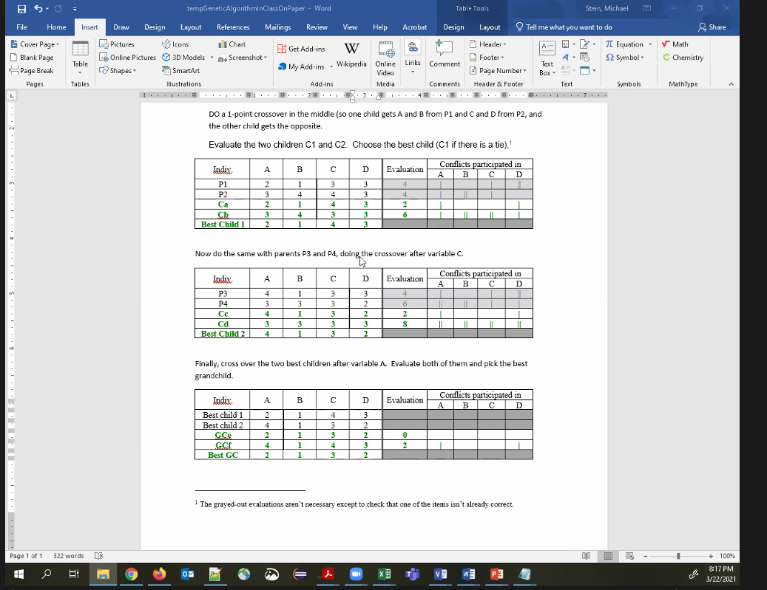

1. The grayed-out evaluations aren’t necessary except to check that one of the items isn’t already correct.